Introduction to Computer Security – G6077
Part A: Principles, User Authentication, Malware
Task 1
- Using two words that is highly predictable, “crazy” and “pass”, by just changing letters to numbers or symbols is not secure enough as those combinations can be in many wordlists. In Addition, 9 characters, which is not too complex to brute force. However, it is not easily guessable so, it is suitable.
- Qwerty is one of the most known internet “phrases” and will be in a dictionary which makes the password vulnerable for dictionary attacks, and it is not long enough to be secure. So, it is unsuitable.
- It is a long password with symbols which makes it somewhat secure, but “laptop” and “admin” are computer terms that will be commonly in wordlists. It would be difficult, but a dictionary attack could eventually crack this password. So, it is suitable.
- There is no character complexity and it is too short, which makes this password easily cracked by not even dictionary attack but brute force. So, it is unsuitable.
Task 2
- Upon signing up users are assigned a password by the system. This is not safe because the password is made by concatenating two words from a list called passwords, which has simple and short words, and the txt file is not encrypted.
- To improve this, a more complicated password list can be used, which have to be stored encrypted, if the implementation of users setting their own passwords upon signing up is not possible.
- After users change their passwords, their new passwords are saved without being hashed, into a Microsoft database, which is not encrypted. This is highly vulnerable.
- Access to the database absolutely needs an upgrade to require an authentication. Moreover, instead of storing passwords directly in the database, hashed values of passwords have to be stored. This would increase security even if the authentication of the database is exploited.

Part B: Digital Forensics
Task 3
Password: 0987
- Get the hash data from pdf file by running pdf2john.pl.
- Create wordlist with crunch, from four digits, using ascii-32-95 charset.
- Crack the password using john on hash file with the wordlist.
- I have piped crunch results to john while solving this but still created and included the dictionary in the submission file as pass.txt

Part C: Encryption
Task 4
- Run a frequency analysis to find the most used letters.
- Run a bigram and trigram analysis to find letters used most together.
- Compare results to letter, bigram and trigram frequency in English language.
- Substitute possible letters and find a word within the cypher to confirm each letter one by one.
Decrypted message:
WALRUS SAID TO TALK OF MANY THINGS OF SHOES AND SHIPS AND SEALING WAX OF CABBAGES AND KINGS AND WHY THE SEA IS BOILING HOT AND WHETHER PIGS HAVE WINGS BUT WAIT A BIT THE OYSTERS CRIED BEFORE WE HAVE OUR CHAT FOR SOME OF US ARE OUT OF BREATH AND ALL OF US ARE FAT NO HURRY SAID
Task 5
p=13; q=31; e=19; m=2
p * q = n 13 * 31 = 403
(p – 1) * (q – 1) = PHI 12 * 30 = 360
(d * e) mod PHI = 1 (d * 19) mod 360 = 1
19 * 19 = 361
361 mod 360 = 1, d = 19
Encryption (n, p) = encryption (403, 19) = cipher = me mod n = 219 mod 403 = 388
Decryption (n, d) = decryption (403, 19) = decipher = cd mod n = 38819 mod 403 = 2

Part D: Challenge
Task 6
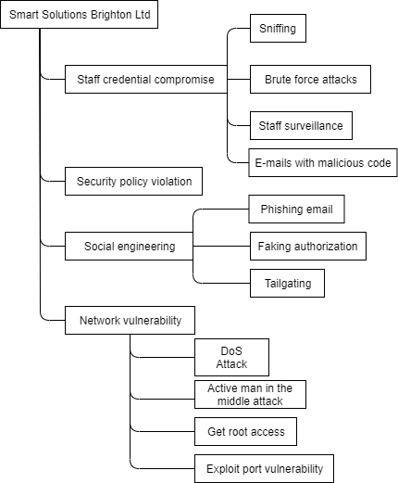
Task 7
Home page for the application is http://88.97.108.163/assignment/login.php. If the user wants to register, there is a link at the bottom. Upon registration a user name, password and password confirmation are required. Password cannot be less than 8 characters and it cannot contain username in it. Naturally, username and password cannot be empty, or username cannot be the same with an existing one in the database. Database holds accounts with an id, username and password, where every password is hashed by php built in function. After creation of a user in the database, the user then can login through the login page. Once the user logged in, then the user can choose to logout, which takes the user back to login page, or upload a file. When upload file button is clicked, the user is taken to a page where they choose the file and submit by another button. In the case where the file does not have the correct extension, an error occurs as the file must have docx, doc or pdf extensions, as the system would only allow those formats to be uploaded.

Task 8
I have not attempted this task.

